**MECHANIC FINDER WEB APP**

**By**

**GROUP BSE22-20**

**DEPARTMENT OF INFORMATION TECHNOLOGY**

**SCHOOL OF COMPUTING AND INFORMATICS TECHNOLOGY**

**A Project Proposal Submitted to the School of Computing and Informatics Technology for the Study Leading to a Project in Partial Fulfillment of the Requirements for the Award of the Degree of Bachelor of**

**Sciences in Software Engineering Of Makerere University**

**Supervisor**

**DR. RASHIDAH KASAULI**

**Department of Information Technology**

**School of Computing and Informatics Technology, Makerere University** [**rashidahk@gmail.com**](mailto:rashidahk@gmail.com)

**Supervisor Signature:_________________________**

BY

|  |  |  |
| --- | --- | --- |
| **NAME** | **REGISTRATION NO** | **STUDENT NO** |
| **RACKARA ANDERSON** | **18/U/23386/EVE** | **1800723386** |
| **SSEBALAMU RONALD GGAANYA** | **18/U/23401/EVE** | **1800723401** |
| **SSEKKAKA MAHAD** | **18/U/23442/EVE** | **1800723442** |
| **AMANYIRE RAYMOND** | **18/U/23443/EVE** | **1800723443** |

**Abstract**

In Uganda, a lot of people are facing difficulties getting help when their car breaks down on the road. Many of them do not have any Car Repair Service Providers’ contact number and could not get help as the Car Repair Service Providers might be far away from their locations. These problems are the motivations for the development of this project to help those who are in need when their car breaks down along the roads.

We therefore managed to use a sample of 30 respondents and these include; long distance drivers, town-service drivers, as well as mechanics from Kampala, Mukono and Wakiso both male and female of ages ranging from 18-50 years. This sample was a close estimate to our project since its main objective is to cover the above mentioned districts. This project will start with the analysis of the car breakdown incidents on the road and their impacts in the transportation industry.

Furthermore we display an analysis and comparison of those existing Car Breakdown Service portals or applications to identify the flaws. Development of a Mechanic Finder Application will be carried out after planning and analysis. Internal testing and user testing of the application will be carried out before the system is being deployed. As part of the expected results, the proposed system connects mechanics and the Car owners through this system. If the car owner's transportation breaks down on any highway or road along the mentioned districts, the owner could enter information with regards to the place of breakdown in the system using mobile phone, tablets. The system will automatically search for any mechanic nearest to the reported incident spot. The user is able to contact the mechanic to service the vehicle. This project aims to develop a Mechanic Finder Application. The proposed system connects mechanics and the car owners through this system.

**Acknowledgment**

It would be unfair and unkind not to acknowledge the guidance, intelligence and patience of our project coordinator, Dr. Mary Nsabagwa and our project Supervisor Dr. Kasauli Rashidah who have shared with us while working on this project. We are incredibly grateful for their vision and his persistence upon the values of hard work, helping others and not losing morale.

We thank all the participants who cooperatively worked with us in our data collections they proved very helpful and offered us a wealth of insight.

Supervisor signature:________________________

Table of Contents

1. Introduction 5

1.1 Purpose 5

1.2 Objectives of the data collection study 6

1.3 Problem Statement 6

1.4 Project Scope 6

1.5 Definitions, Abbreviations and Acronyms 6

2. Literature Review 7

2.1 CaRiger 7

3. Methodology 8

3.1 Introduction. 8

3.2 Research Design. 8

3.3 Population 8

3.4 Sample Size 8

3.5 Sample Procedure 9

3.6 Instrument for data collection 9

3.6.1 Primary data 9

3.6.2 Secondary data 9

3.7 Procedure for gathering data 9

3.7.1 For the Interviews 9

**3.7.2** **Before administering the interviews.** 10

**3.7.3** **During administration of the questionnaires** 11

**3.7.4** **After the administration** 11

4. Results 11

4.1 Online survey results. 11

5. Interpretation of Results 18

5.1 Introduction 18

5.2 Online survey Results Interpretation. 19

6. Conclusion 20

7. Recommendation 20

8. References: 21

# Introduction

Over the last two decades, the business environment evolved drastically; this has been characterized with the way how people and businesses interact with each other.

This has been realized due to the introduction of the Internet and Information technology that has changed the concepts of marketing, advertising, provision of services and the entire business sphere.

After a couple of engagements with car owners and mechanics, it has been realized that vehicles breakdown on a day-today basis across the country, not to mention the effect it causes to both the vehicle owners who at times fail to reach their desired destination on time and missing schedules. And at times for some cases, cars may break-down on the highways, with no nearby mechanic to troubleshoot them, this enormously increases the level of traffic jam on the road.

## Purpose

The purpose of the document is to collect and analyze all assorted ideas that have come up to define the system, its requirements with respect to consumers. Also, we shall predict and sort out how we hope the Mechanic Finder Application will be used in order to gain a better understanding of the project, outline concepts that may be developed later, and document ideas that are being considered, but may be discarded as the product develops.

## Objectives of the data collection study

* The need to pair vehicle owners with expert mechanics around their area.
* Secondly, the need to provide good jobs to the skilled persons of our society. Because most of mechanics face difficulty of space rent and low frequency of customers.
* The need to assist mechanics in scaling their services to support the market demands. This is because the MFA will be able to schedule and/or pair the vehicle owners to the available mechanics 24/7.

## Problem Statement

Car owners who drive both on long distances and casual town service usually have a difficulty on locating mechanics when they move to an unknown place. This leaves them with little to no option to locate a Samaritan to direct them to the nearby mechanic. This may delay the car owner’s operations in case he wants to rush to his or her routine duties.

## Project Scope

Our project was specifically concentrated in three main districts namely; Kampala, Wakiso and Mukono.

During our survey, and more studies from the UBOS ( Uganda Bureau of Statistics), these are districts with a large sum of vehicles in the entire country. Furthermore, the accessibility to both internet services and infrastructure, as well as the level of education of the people will likely promote our web application to fully meet the demands of both the drivers and the vehicle owners.

Our project will therefore operate in Kampala, Mukono and Wakiso.

## Definitions, Abbreviations and Acronyms

**MFA- Mechanic Finder App,** the web application that this report describes, one which simulates a real life conversation and allowing users to perform a sequence of actions which include; locating, pairing vehicle owners to nearby mechanics.

**GPS- Global Positioning System**, utility that provides users with positioning, navigation, and timing (PNT) services. This will enable the vehicle owners and mechanics to display their presence on a map.

# Literature Review

GPS common/all-view method is one of the main tools for long-distance time and frequency transfer (Huang Yan, 2014). Its core is the GPS time transfer receiver and post-processing algorithms. The high real-time multi-channel GPS time transfer receiver based on EURO-160 GPS board and the real-time data processing algorithms.

Technology has advanced in a vast number of ways, this has created a platform for automation in all aspects of the business chain more so in the 21st Century, with the rise of Artificial intelligence which incorporates chat bots; which are programs that interact with users using natural languages(Shawar, 2007)these have provided a large amount of support for this.

Chat bots are digital assistants who are able to provide information, answer questions, discuss a particular topic , or perform a task(Smutny &Schreiberova, 2020). This module of delivering information is important because it enables people to access services they require much faster and easier.

The GPS navigation system presented provides very useful information about present geographical information which includes latitude, longitude, altitude, current velocity and Greenwich meridian time reference (Sonal N. Parmar, 2014). It is capable of indicating active and inactive PRN number (pseudo random code) of satellites used for GPS tracking in terms of visual plane positioning indicator system.

Below are some of the projects that have been developed to enable car owners to locate respective mechanics in their areas of Car breakdown.

## CaRiger

This web application provides services in Karachi, Pakistan. It helps you maintain your car as well as repair your car in case of accidents. It also provides updates about new vehicle brands. User can book an appointment without creating an account and the staff call the User for location detail and other detail.

For the case of MFA, our 24/7 Chat bot will be able to assist our clients in case of any queries and follow-up on their appointments with the mechanics. Cariger has no such feature. This will further improve our customers’ user experience.

# Methodology

## Introduction.

This chapter presents the methodology that was used in the study. This included research design, area of study and target population, and selection of respondents, data collection methods, data quality control, and data analysis.

## Research Design.

The study used a descriptive survey design in a particular descriptive correlation design with the reason and we wanted to find out the following objectives

* Is the proposed system capable of solving the current problem of locating mechanics for both local and long distance drivers?
* The need to find out whether the customers are willing to comply with the new system of locating mechanics around their areas.

## Population

The population of this study were the three districts; Kampala, Wakiso and Mukono where the project is going to operate. This population gave us an exact approximate for on what our expectations should be when designing the final system.

This is because 65% of the vehicles in Uganda are in these three districts.

## Sample Size

In the study, the sample of 30 respondents was got from the population, and this included car owners and mechanics both men and women from ages 18 – 50 years.

## Sample Procedure

We used Purposive sampling technique. Purposive sampling technique was used to select both car owners or drivers and the mechanics. This form of sampling enabled us to get low margin errors in our computations since the respondents were people selected random from the pubic ranging from car mechanics working on yesterdays’- unfinished work at a garage to normal taxi drivers parking in the garage waiting for their vehicles to be cleared from the garage. Under this format we used both Interviews and questionnaires.

## Instrument for data collection

### Primary data

The research instrument used to collect primary data was questionnaires and interviews.

The questionnaires collected data to determine the level of compliance for both car owners’ and mechanics’ compliance to the new system of locating mechanics near them. These were drafted in google documents that were shared online to car owners in Kampala.

For the case of interviews, we made a tour to six garages along Sir Apollo Kaggwa Road, where we interviewed mechanics randomly about their views on the system.

### Secondary data

We further utilized available secondary data sources which included personnel and record departments of the institutions, text books, journals, local newspapers , internet, among other sources so as to ensure critical evidence and areas of reference.

## Procedure for gathering data

### For the Interviews

These we carried out face-to-face with a mix of individual and group oriented interviews based on our interviewees. These were formal , semi structured interviews in which we recorded all responses given to us on paper and we used a set of predefined questions added spontaneously during the execution of the interview to collect additional information.

These we conducted in teams of two and recorded all the responses from our interviewees on paper.

Below is a list of the questions we asked in our interviews for Mechanics.

1. How do you acquire costumers?
2. How many hours do you work in a day?
3. How do you ensure that costumers automobile is fully serviced?
4. In case a Vehicle fails to function well after servicing or diagnosis, how do you ensure that costumer leaves with a smile?
5. Is there a standard price with which you can work on a broken down car?
6. What is the average amount of money spent on marketing garage per year?
7. Which pressing problem would you want this partnership with Online Mechanic Finder System to solve?

In order, to reach the target number for interviews for the students we decided to make use of an online questionnaire which we passed onto the car owners.

The questionnaire is available as a google form at the link;

<https://forms.gle/v3NJiFtXaEtSVk4n8>

### **Before administering the interviews.**

1. An introduction letter was got from the college of Computing and Information Sciences, under the Networks department of the university to solicit approval to carry out the study from mechanics and car owners.

2. After approval, we got the list of the respondents among car owners and mechanics from the selected garages which include Lilos Garage-Sir Apollo Kaggwa, SMS Garage-Mukono ,T.K Auto Spare Garage-Mukono and Niyo Garage-Wakiso Using the systematic random sampling technique, the sample size was drawn from the population of the mechanics in each specific garages.

3. We sent out more than enough questionnaires using Google forms for the car owners who couldn't keep in touch with the interviews.

### **During administration of the questionnaires**

1. We distributed the questionnaires to the respondents, and we were brief and oriented them in order to have consistency in the data.

2. We emphasized the retrieval of the answered questionnaires right after clicking the submission button at the bottom of the online form.

3. During retrieval all questionnaires were checked to see if they have been fully answered.

### **After the administration**

The data was gathered and statically, it was generated by Google response tool and face-to-face interviews.

# Results

We carried out an online Survey for the drivers since they have more time on their hands and went into the field to gather data from the mechanics who are always busy at their stations and barely get time to go online.

## Online survey results.

We sent out Google survey to over 10 people who have cars and got 10 responses to the survey over time. Below are the results to the survey questions.

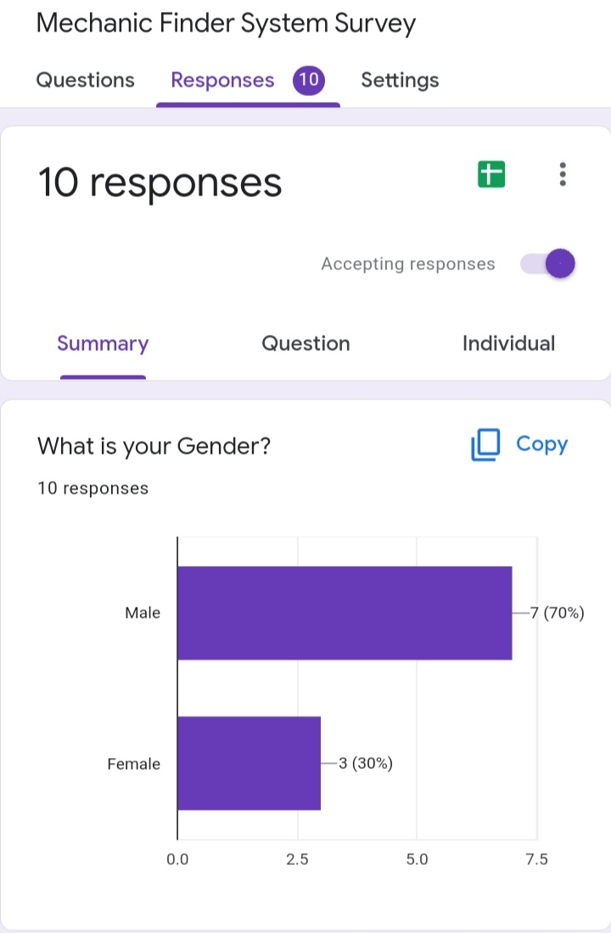

Fig. 1: Gender of respondents

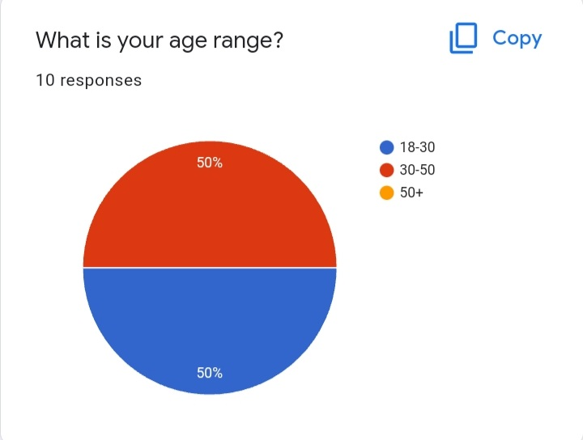

Fig. 2: Age range

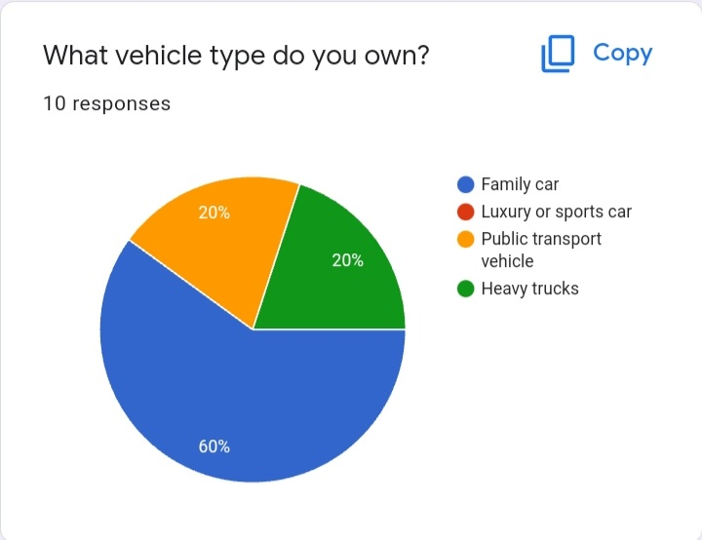

Fig. 3: Car/Vehicle type

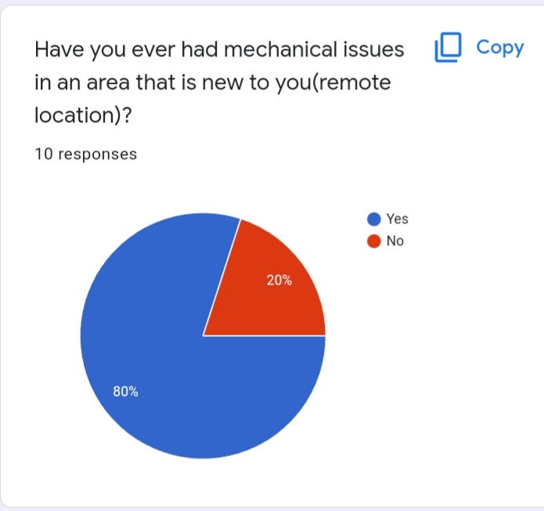

Fig. 4: Mechanical issues

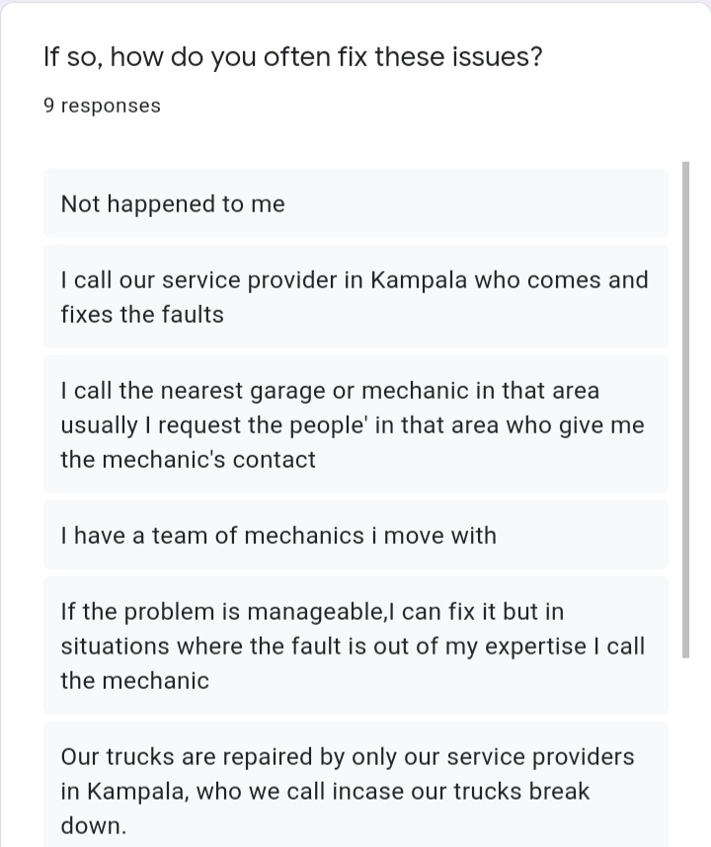

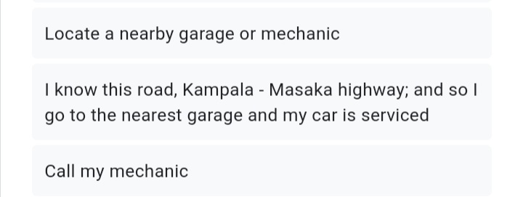

Fig. 5: Mechanical Issues fix response

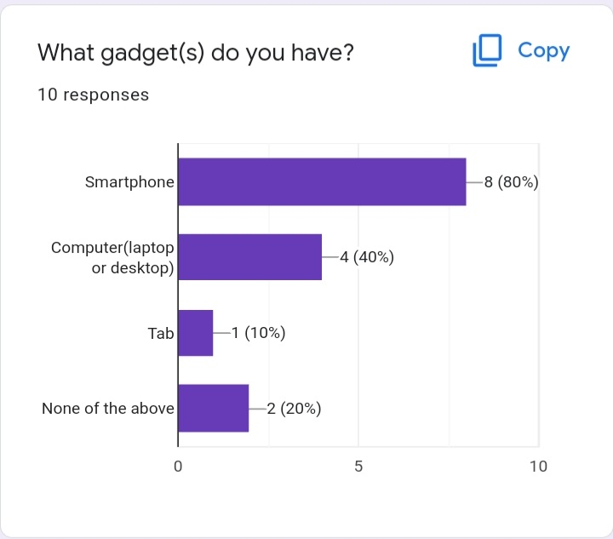

Fig. 6: Gadgets possessed

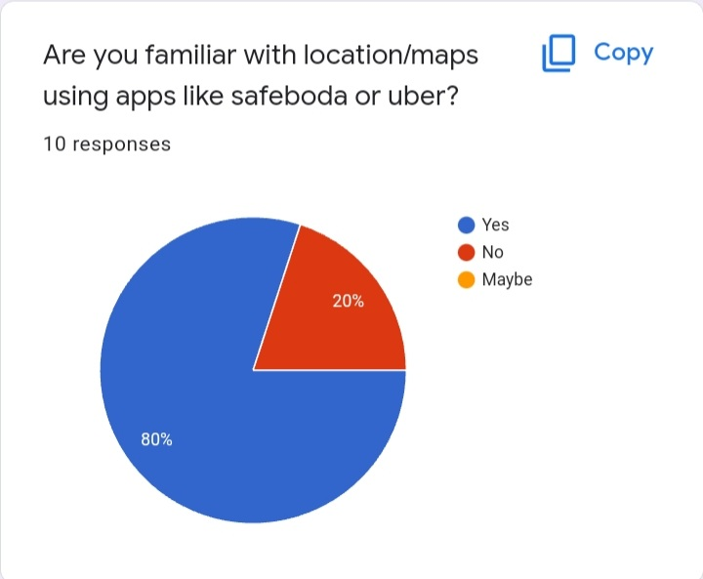

Fig.7: Respondents used locator apps before

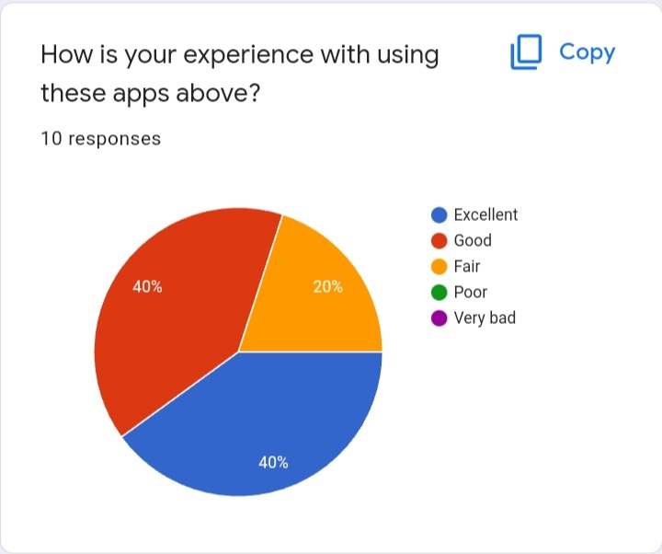

Fig. 8: Experience with locator apps

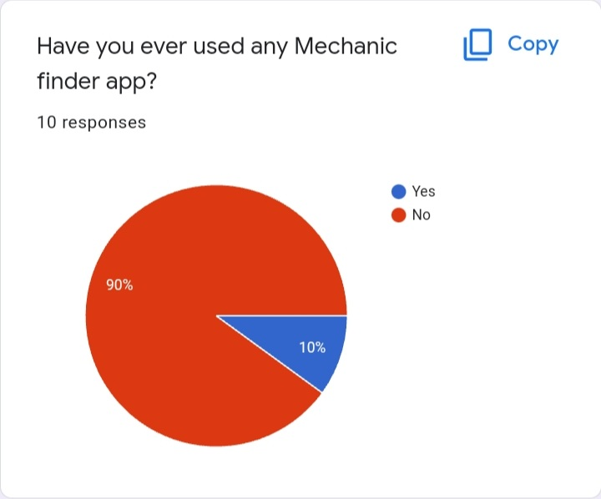

Fig. 9: Used a Mechanic finder App

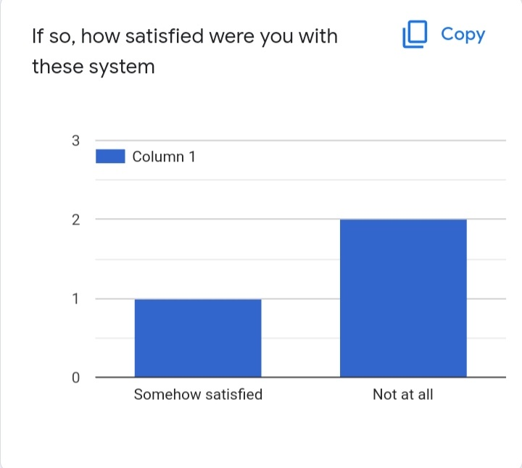

Fig. 10: Satisfaction with Mechanic System

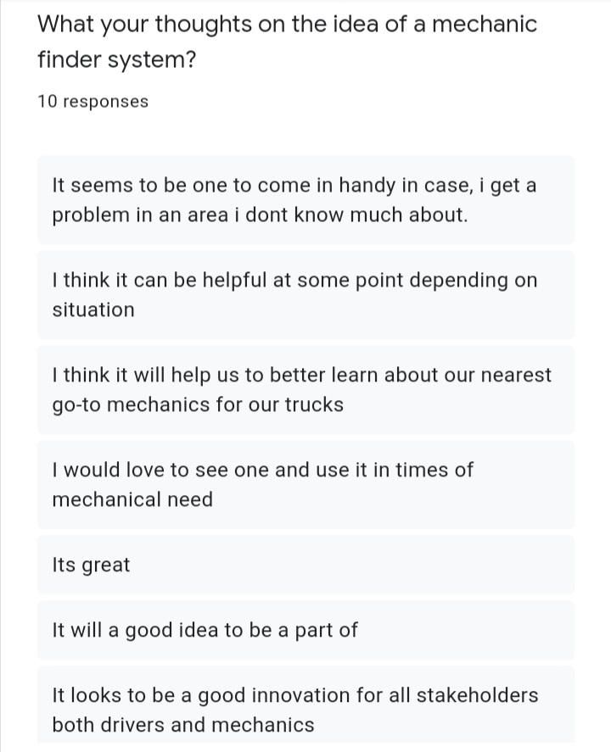

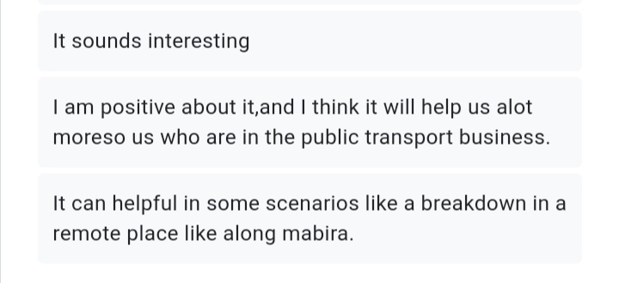

Fig. 11: View on Mechanic Finder System

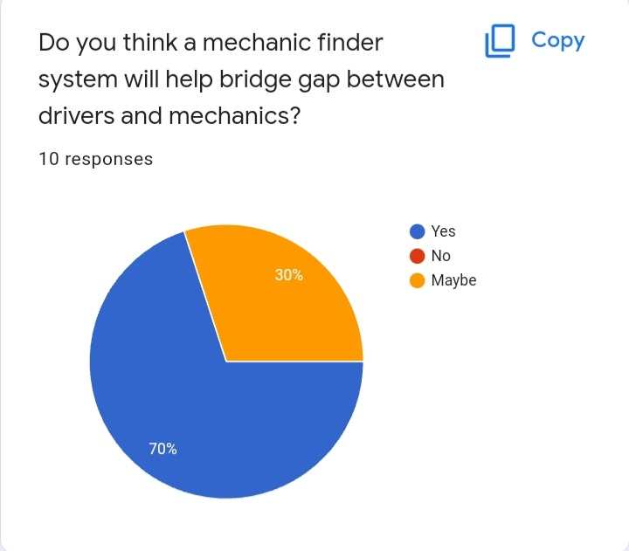

Fig. 12: More View on System

# Interpretation of Results

## Introduction

In this section, the sole focus is on analyzing the data we acquired from the surveys we conducted and generate some more requirements for the system.

## Online survey Results Interpretation.

Below is our assessment of the online survey results.

* According to Fig. 1 & Fig. 2, There were 7 male respondents and 3 female respondents, with age range between 18 to 50 years which sets our domain for target population because they are more knowledgeable when it comes to using modern technology.
* From fig. 3, 60% of respondents owned family cars, 20% owned transport vehicles and rest owned heavy trucks which means survey covered most of the existing road users
* From fig. 4 and 5, it showed that most of the respondents had ever experience mechanical issues in a remote area and used several means to fix the issues like repair by self, calling personal mechanic, locating nearby garage which supports the main reason for the system that is to bridge that gap and make it easier for a driver to do that.
* According to fig. 6, most of the users had at least a gadget which is a hardware requirement on the system will operate.
* From fig. 7 and 8, 80% of the respondent have ever used location apps like Safeboda and Uber which operate like the proposed system and have an averagely good experience using them, which skill set required to learn how to use the mechanic finder system since it requires GPS.
* From fig. 9, 1/10 respondents had experience using a ,Mechanic finder App and was somewhat satisfied with it, which shows that there is an opportunity here.
* Fig.11 shows that the respondents had highly positive perceptions towards the online Mechanic finder App which gives more purpose and drive to develop project
* Fig. 12 shows that 80% of respondents agreed to that system can bridge that gap between car owners and mechanics and 20% were skeptical with a maybe thought which shows the need for the system to be developed
* Meanwhile we failed to hit our targets due to some of the challenges;
  + 1. Inadequate resources more so financial resources since our team had to pay for Internet services inform of mobile data, pay for secretarial services to print interview questionnaires, and transport costs since our research team had to move from place to place looking for data relevant for this study. But this was solved by soliciting for funds from all available sources and these were our friends, parents.
    2. There was also a serious problem of non-response by the respondents. Some respondents refused to provide information and asked a lot of questions, others were too busy to be contacted for information, this made the researchers to miss out important data for this study. The busy schedule of the respondent was also be a problem in that the researcher hardly got time to discuss with the respondents and for them to fill the questionnaires, this was solved by making appointments on phone.
    3. Difficulty in identifying garages in places like Wakiso and Mukono. This is because some of the garages were far from reach. This meant more transport costs had to be incurred as well as the long schedules to conduct the data collection process.

This shows there are several cases of vehicle break down, drivers and mechanic are sure that this system will solve the problem of delays along the road by drivers and also create opportunities to mechanics through linking them with the vehicle owners/Drivers.

This will create a stable flow of income for mechanics, spare-parts sellers and the sector of automobiles in general.

# Conclusion

Since the chances of a properly maintained vehicle experiencing a breakdown are relatively small, it is never a possibility to predict when the user may experience a vehicle breakdown. The system developed here promises to make the life of a vehicle owner that much easier, that even in a situation(s) of a breakdown, the vehicle owner is assured of the fact that he has a solution to the problem with in a few steps of entering details in his smart phone can save him from a major setback and get his vehicle up and running. The proposed system will act as a source of protection against the unpredictability of any vehicle breakdown.

# Recommendation

In consideration to the findings of our research study, the following are the recommendations that we suggest as possible solutions to aid in solving the problem of vehicle owners finding the mechanics near them by time of the car breakdown.

We therefore recommend an interactive AI and GPS-powered system for all operating systems of smart phones. The system will be created to provide services provided by mechanics at various locations.

# References:

Shawar, B. A. (2007). Chatbots: Are they Really Useful. *Academia*, 29-49.

Smutny, P., & Schreiberova, P. (2020). Chatbots for learning: A review of educational chatbots for the Facebook Messenger. *Computers & Education*, 2-10.

Winkler Rainer, S. M. (2018). Unleashing the Potential of Chatbots in Education: A State-Of-The-Art Analysis. 2018. *Academy of Management Annual Meeting (AOM)*, 10-45.

Alepis, E., & Virvou, M. (2011). Automatic generation of emotions in tutoring agents for affective e-learning in medical education. Expert Systems with Applications, 38(8): 9840–9847.

A public safety application of GPS-enabled smartphones and the android operating system"- Systems, Man and Cybernetics, 2009. SMC 2009. IEEE International Conference-Whipple, J.Inf. Syst. Eng. Dept., Southwest Res. Inst., San Antonio, TX, USA Arensman, W. ; Boler, M.S

Automobile Service Center Management System", International Journal of Scientific and Research Publications, Volume 4, Issue 3, March 2014 , Prof. Shilpa Chavan Saket Adhav, Rushikesh Gujar, Mayur Jadhav, Tushar Limbore (Padmabhooshan Vasantdada Patil Institute of Technology, Pune

Maruti Techlabs. (2018). Why can chatbots replace Mobile Apps immediately? Retrieved March 9, 2019 from: https://www.marutitech.com/why-can-chatbots-replace-mobile-apps-immediately/

Nguyen, M. (2017). How artificial intelligence & machine learning produced robots we can talk to. Business Insider. Retrieved March 9, 2019 from: https://www.businessinsider.com/what-is-chatbot-talking-ai-robot-chat-simulators-2017-10

Simply learn (2018). Machine Learning Basics. Retrieved March 9, 2019 from: https://www.youtube.com/watch?v=ukzFI9rgwfU

Sproutsocial.com (2018). A complete Guide to Chatbots in 2018. Retrieved March 9, 2019 from: https://sproutsocial.com/insights/topics/chatbots/

 Hattie, J. (2012). Visible learning for teachers: Maximizing impact on learning: Routledge. https://chatbotsmagazine.com/a-visual-history-of-chatbots-8bf3b31dbfb2

Lip ko, H. (2018). Meet Jill Watson: Georgia Tech's first AI teaching assistant. Retrieved on March 9, 2019 from: https://pe.gatech.edu/blog/meet-jill-watson-georgia-techs-first-ai-teaching-assistant.

Chatbot Magazine (2019). A Visual History of Chatbots. Retrieved March 9, 2019 from: https://chatbotsmagazine.com/a-visual-history-of-chatbots-8bf3b31dbfb2

 Colace, F., De Santo, M., Lombardi, M., Pascale, L., Pietrosanto, A. (2018). Chatbot for E-Learning: A Cases Study. International Journal of Mechanical Engineering and Robotics Research Vol. 7, No. 5, September.

 Egencia (2018). What is a Chatbot and How does it work? Retrieved March 9, 2019 from:  https://www.youtube.com/watch?v=38sL6pADCog

[2] Ziebinski A., Cupek R., Grzechca D., and chruszczyk L. (2017)’. Review of advance driver assistance system (ADAS) (DOI: 10.1063/1.5012394).

[7]” Haridas K, Ahmad S. Baharudin, Kamal & karkonasasi (2016)’. Automotive Servicing and Breakdown Assistance System (ASBAS): Impact of Perceived Ease of Use (PEOU)

Kumaar.A, Balakrishna, Subha. S, Harin. K (2019)’. On Road Vehicle Service finder.”

” Kapadi V., Guruju S., & Bojja B. (2017)’. Emergency Breakdown Services using Android Application.”

Miss K Iswarya, Miss. D. Devika, and MR. E. Ranjith. (2010)’. Road Assistance System using GPS. International Journal of Advance Research, Ideas and Innovations in

Technology (IJARIIT).

George A., Beckwith R., Christiane F., Derek G., and Katherine M. (1993)’. Introduction to WordNet: An on-line Lexical Database (pg 1-5).

Wang W., Chen H., and Bell M. (2005)’. Vehicle Breakdown Duration Modelling

On-Road Car Breakdown Assistant Finder

<https://publisher.uthm.edu.my/periodicals/index.php/aitcs/article/view/457>

Vehicle Breakdown Assistance System

http://journals.resaim.com/ijresm/article/view/1880

Book a Mechanic Online| Online

https://www.yourmechanic.com/request-service-online

[ClickMechanic:Book](https://www.yourmechanic.com/request-service-online16%5D.ClickMechanic:Book)CarRepairsbyMobileMechanics

https://www.clickmechanic.com/

[myCANx:FindMobileAutoRepairNearYou](https://www.clickmechanic.com/17%5D.myCANx:FindMobileAutoRepairNearYou)

https://www.mycanx.com/

“Home - MechanicUstaad.pk WaqtBachao -MechanicGharBulao!” *MechanicUstaad.pk*, https://[www.mechanicustaad.pk/.](http://www.mechanicustaad.pk/)

Shop, Mechanic. “We Give You Car.” *AUTOBOYZ*, [www.autoboyz.com.pk/.](http://www.autoboyz.com.pk/)

“Our Process.” *CARiger*, [www.cariger.com/.](http://www.cariger.com/)

“Car Maintenance Made Easy For You Call MOTOFIX for Your Car Repair at Your Doorstep.” *Moto Fix*, [www.motofix.pk/.](http://www.motofix.pk/)

International Journal of Scientific and Research Publications, Volume 4, Issue 3, March 2014 3 ISSN 2250-

3153 <http://www.ijsrp.org/research-paper-0314/ijsrp-p27119.pdf>